**Jenkins Installation and configuration**

1. Before installing Jenkins, install jdk and set path.
2. Install Jenkins(Long term Stable) and run the command java –jar Jenkins.war in cmd prompt.
3. Enter the initial Admin password and install plugins.
4. Install git and maven.
5. Integrate the Git and Maven with Jenkins in Jenkins>Manage Jenkins> Global Tool Configuration..

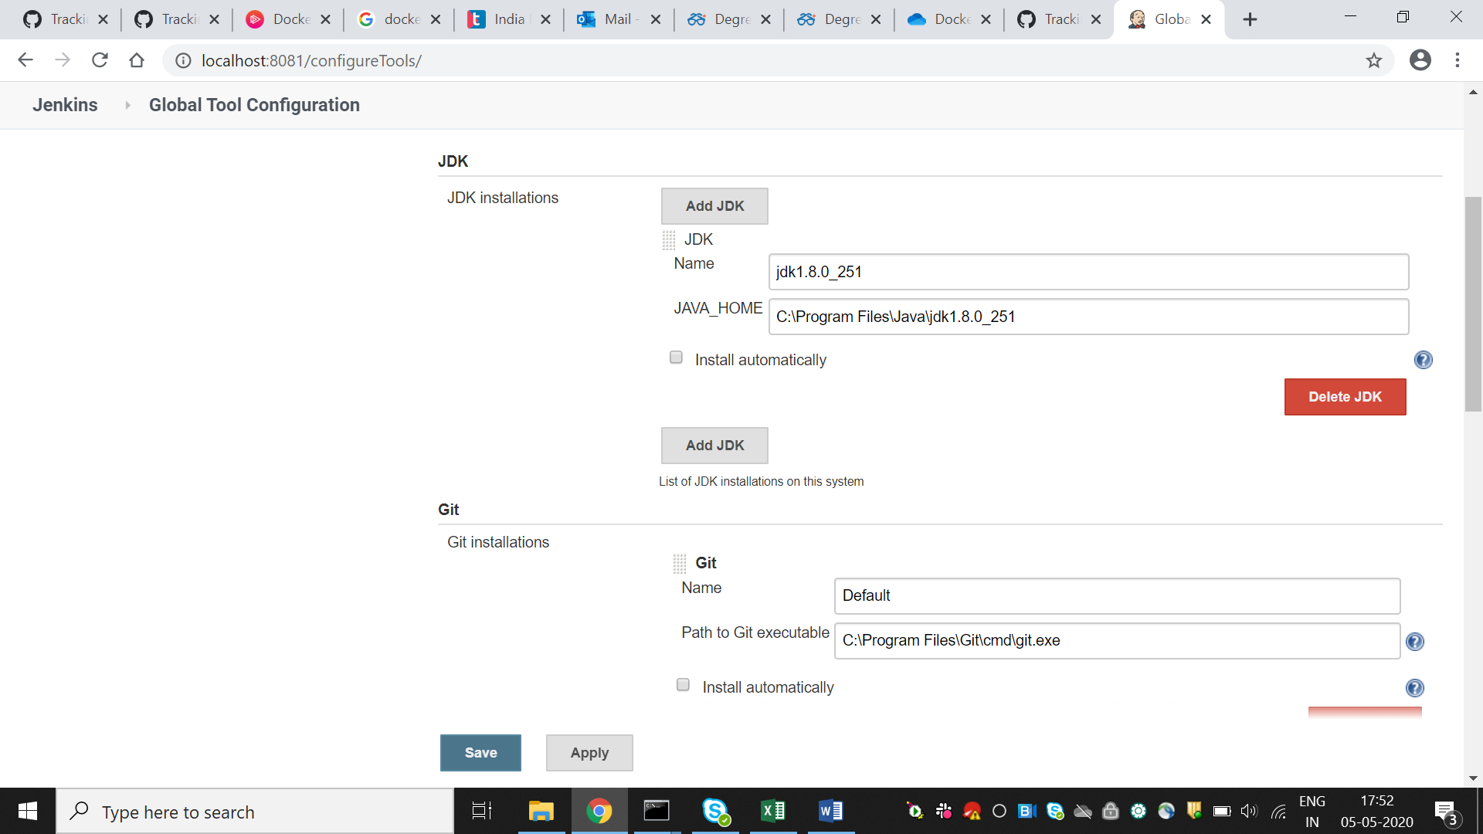

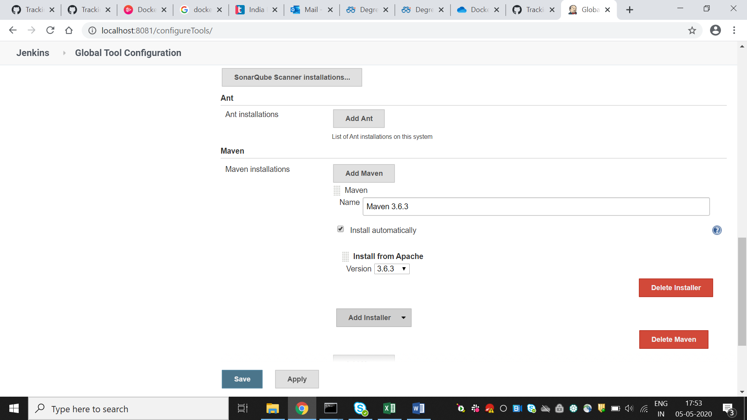

**Jenkins Freestyle Project (BUILD AND DEPLOY ON TOMCAT)**

1. Create a freestyle project.and specify the below options

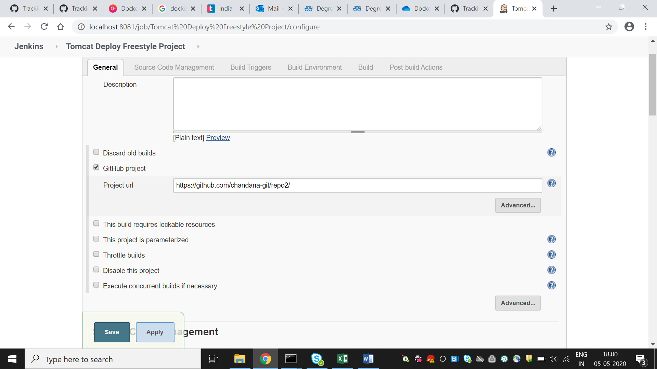

1. Mention the github repo url in which the source code is pushed for undergo build and get deployed.

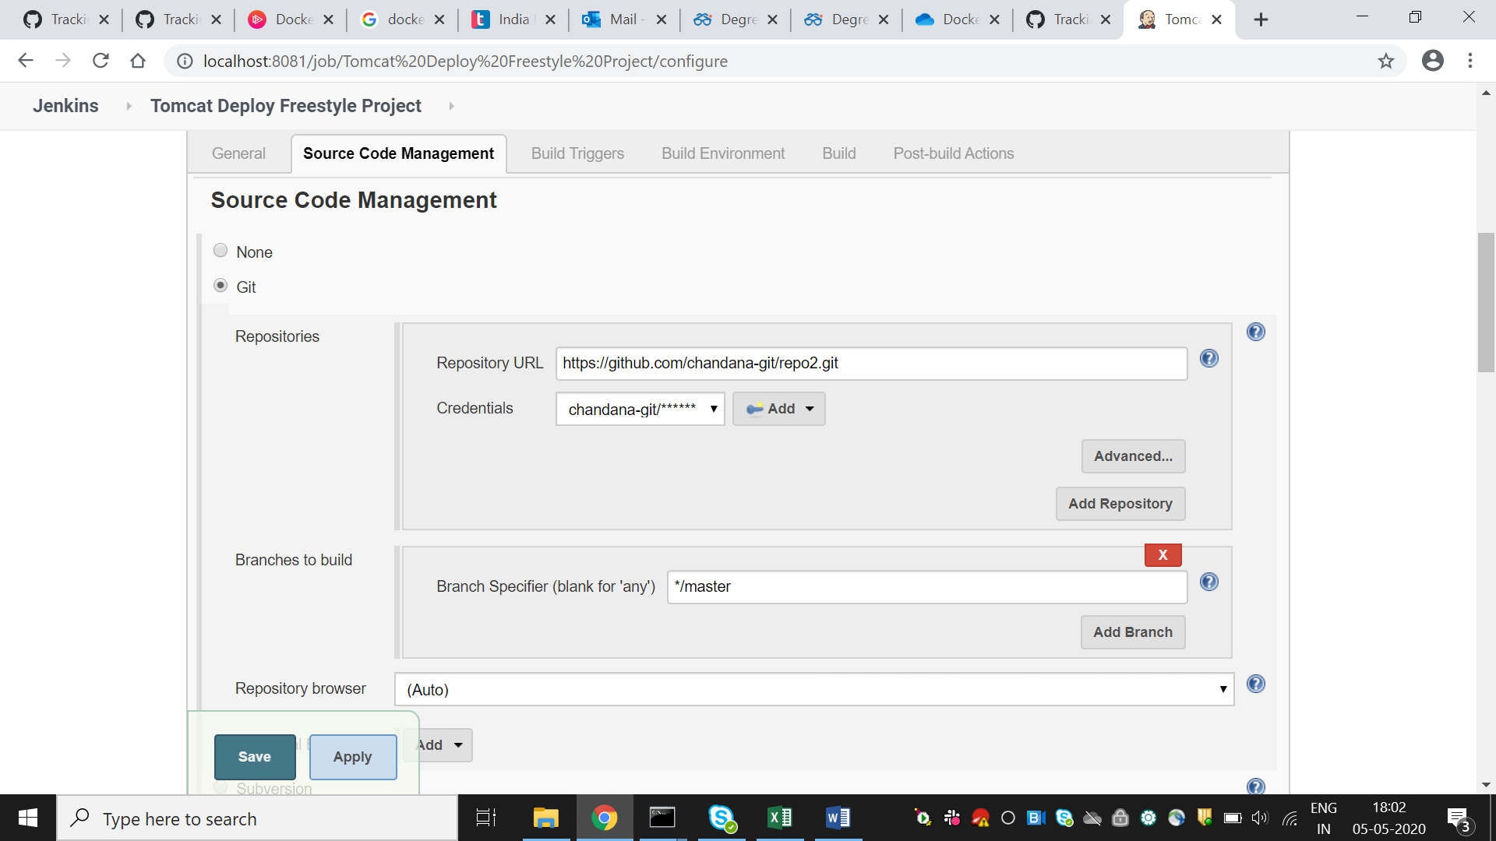

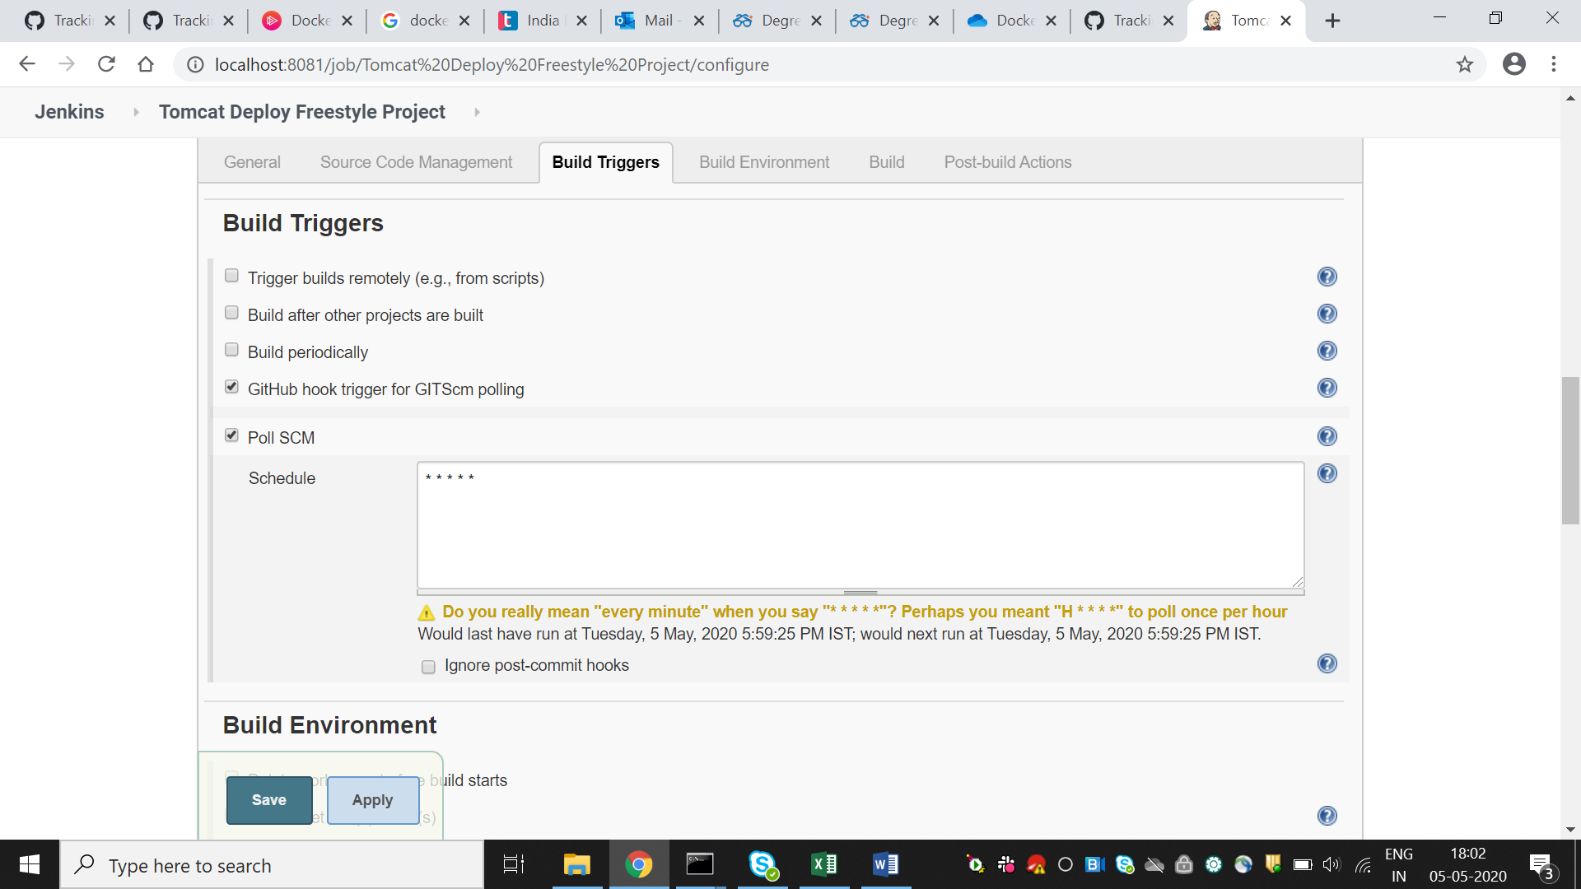

For auto build, we enable Github hook trigger(So whenever there is a commit it starts the build automatically, Poll SCM checks any changes once in a while for which the time is specified)

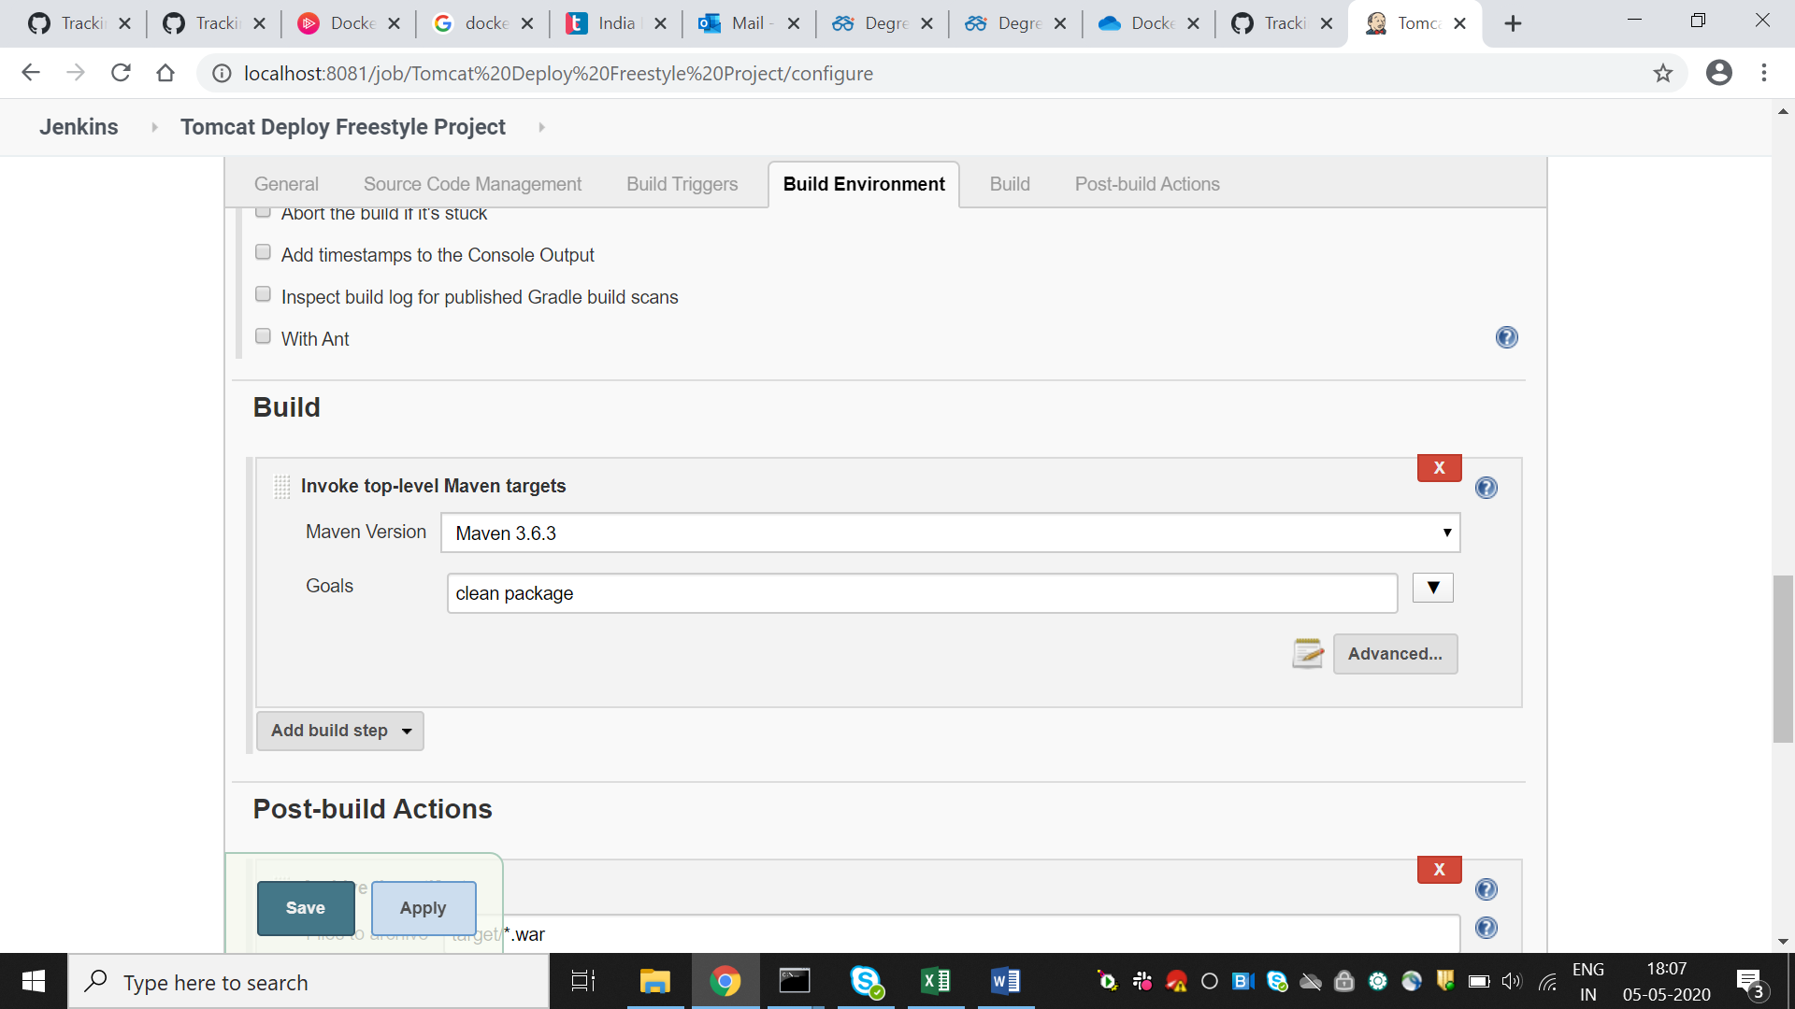

Build step->Invoke top-level maven

Clean and package : Clears the target directory into which Maven normally builds your project and packages into a jar file(clean is used with it to clean up the past build )

Archiving artifacts: To keep a history of the builds and the pakages which are created.

**To configure Tomcat :**Intsall the deploy to container plugin and choose post build actions as Deploy ear/war to a container.

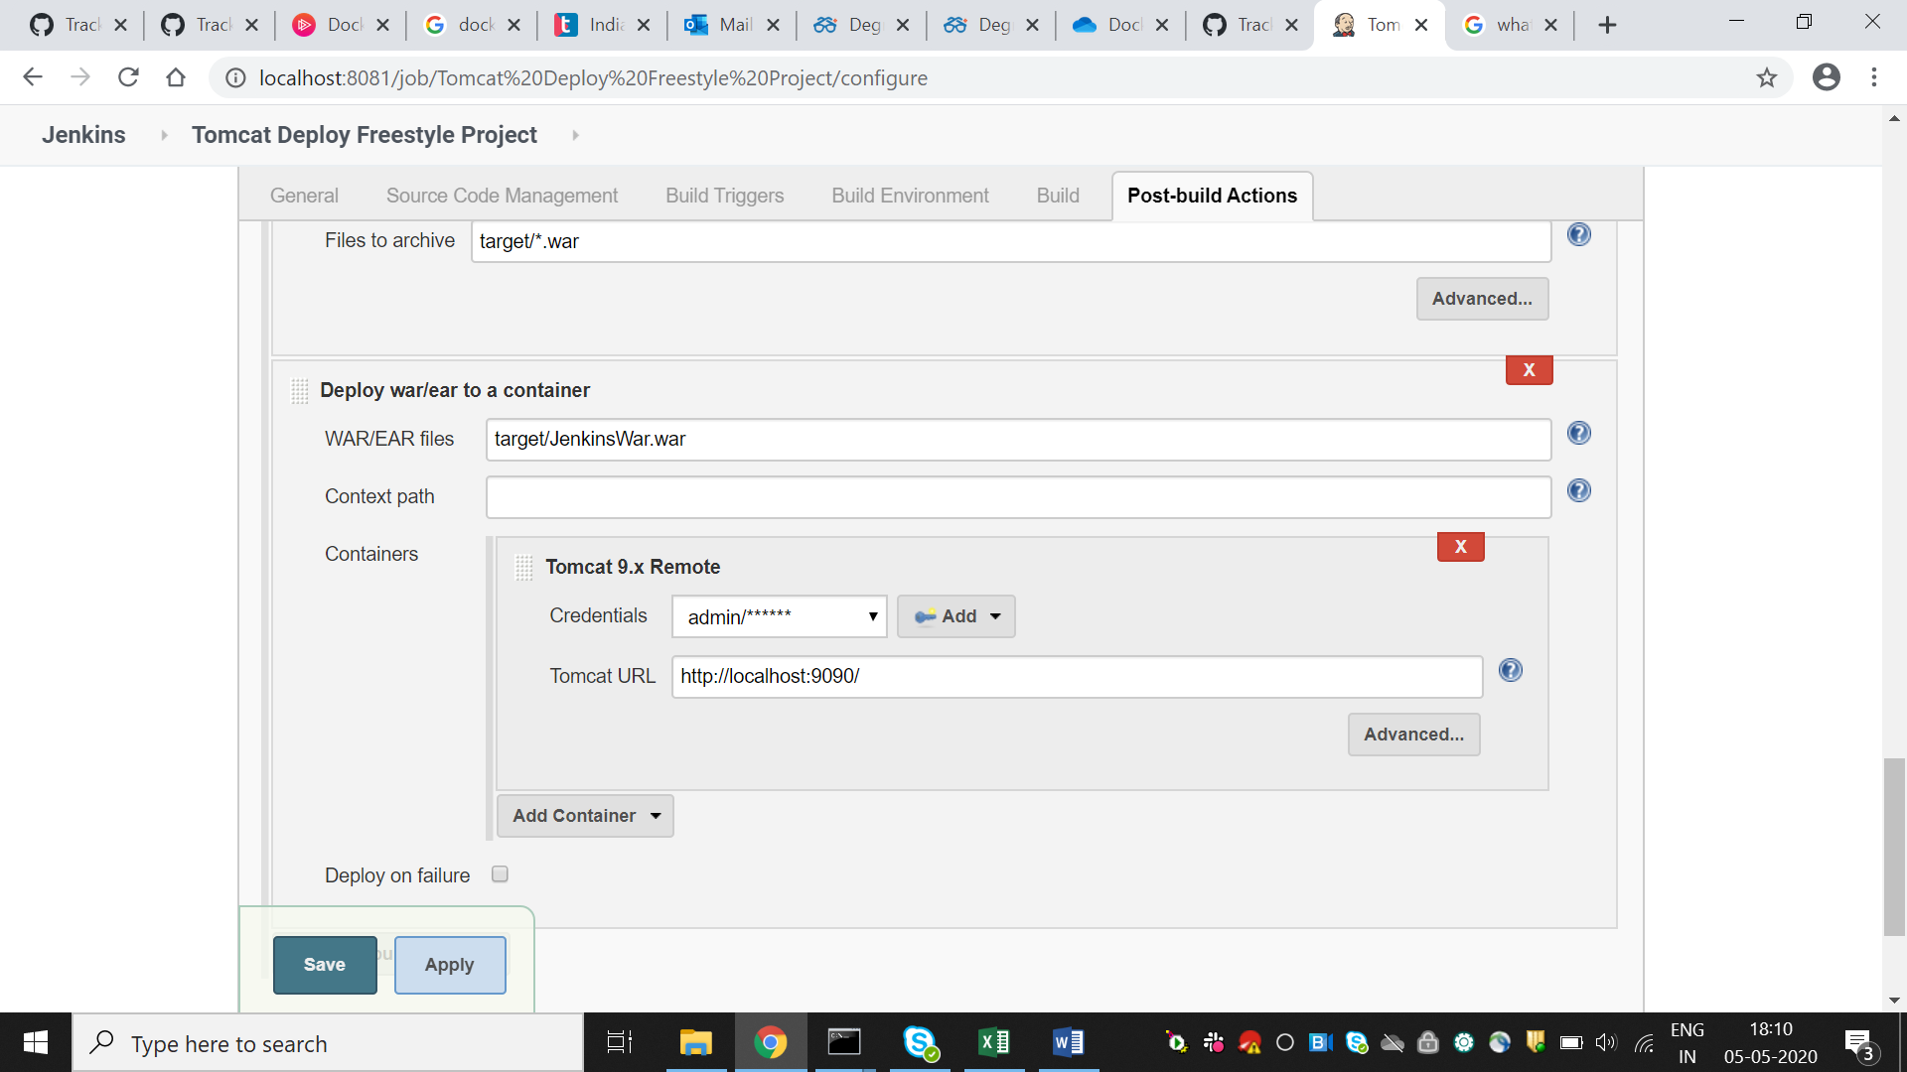

After build ,the job is success

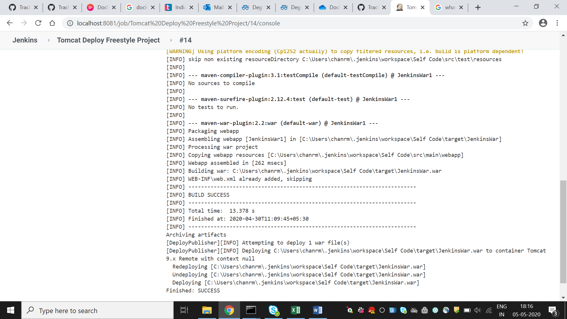

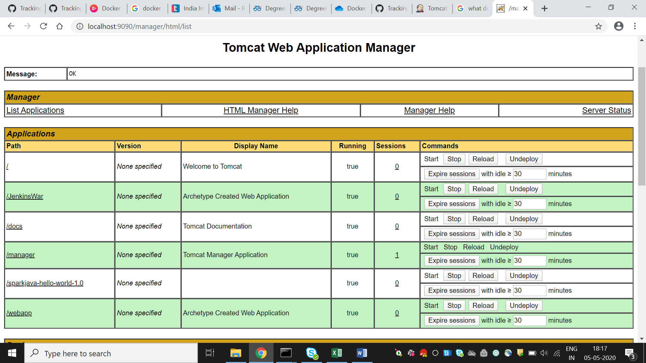

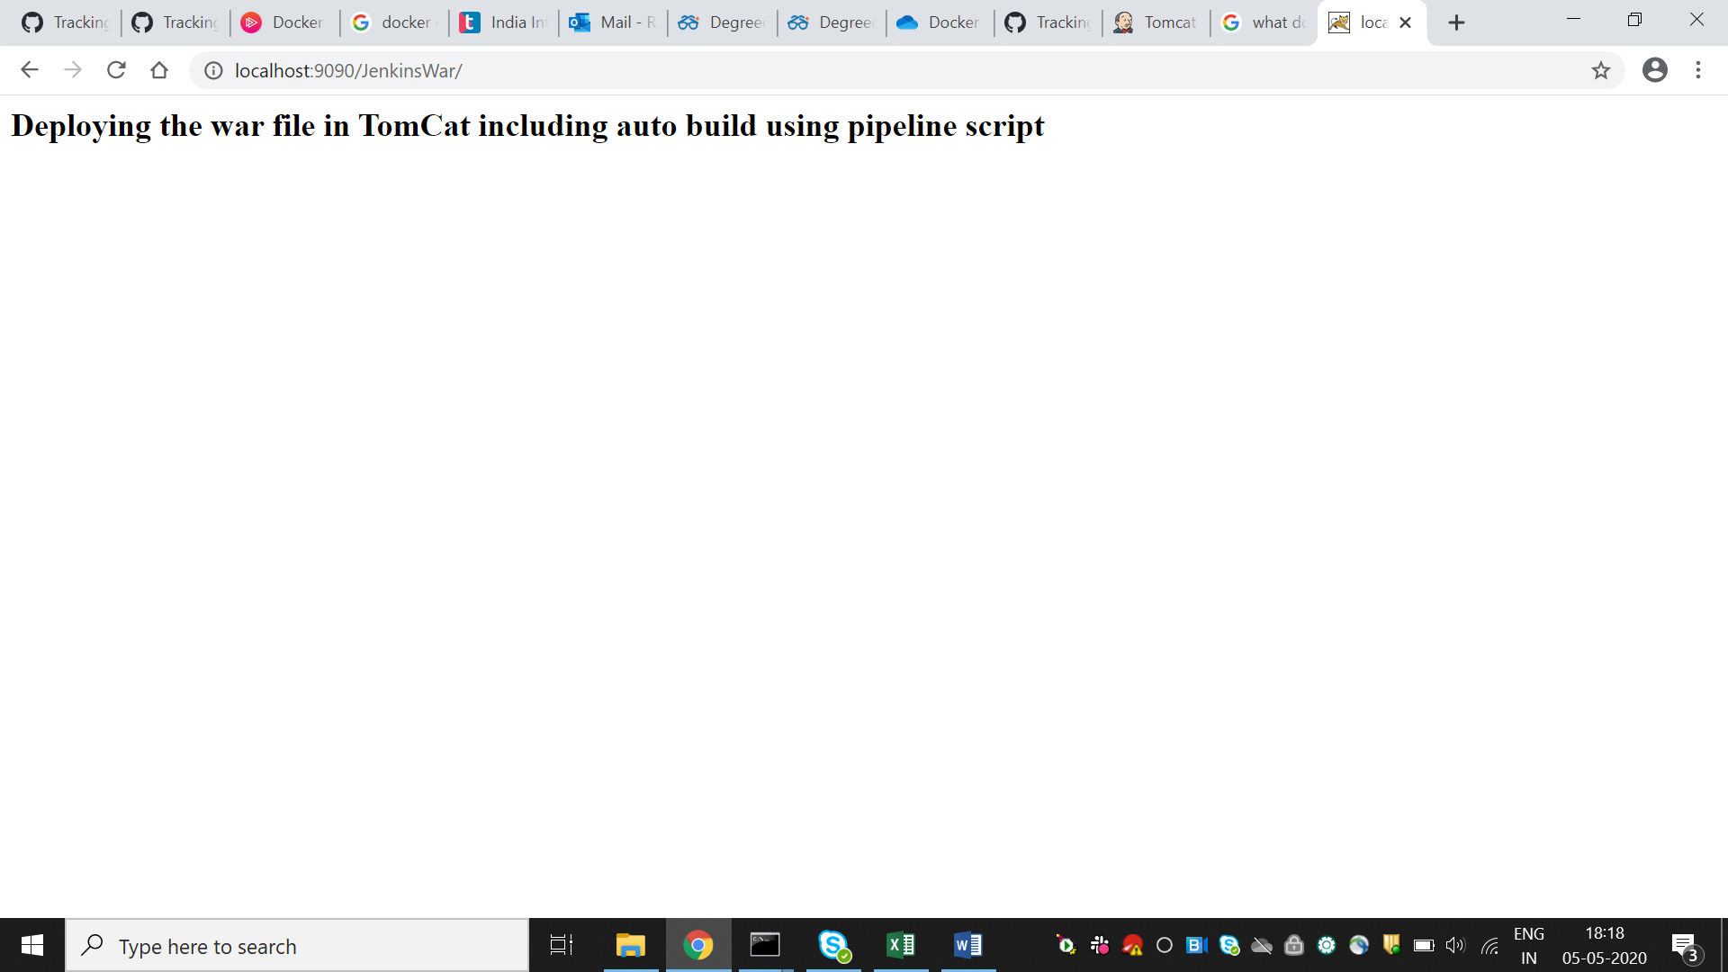

**The** output is deployed on the tomcat.

**DEPLOYING USING PIPELINE SCRIPT**

1. Create a pipeline Job.
2. 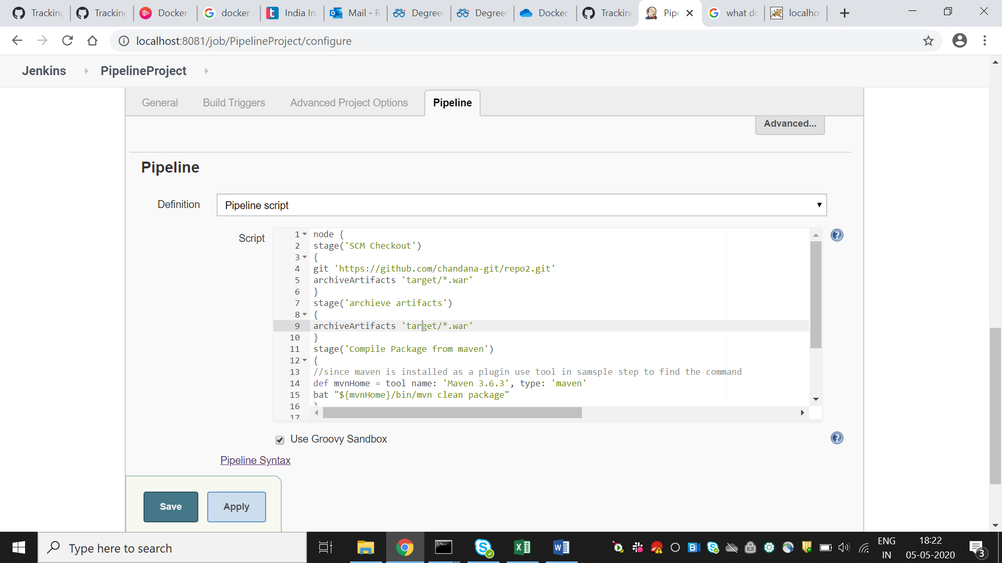
3. Write the script defining each of the options with stages within a node.(You can use Pipeline Syntax for groovy scripts for each of the option for help)
4. Build Now
5. 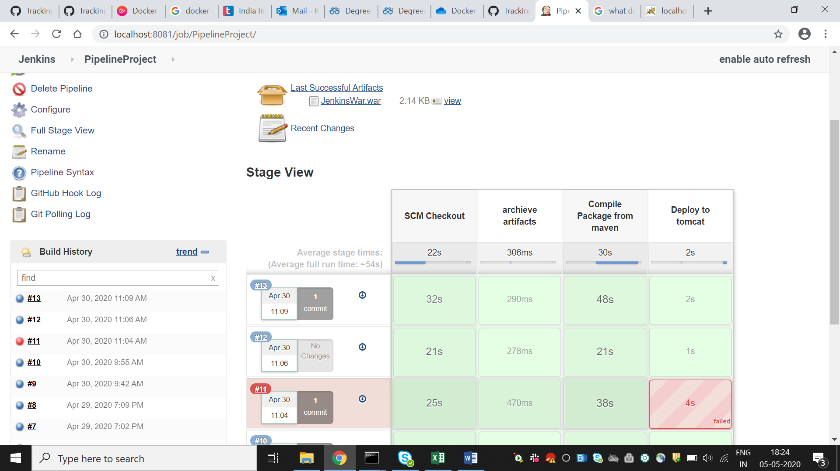
6. 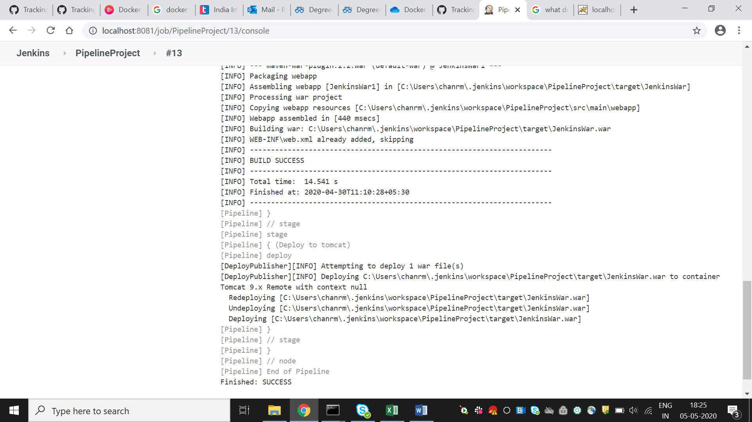
7. 